**Exercise- 12**

**Step 1: First create a folder named** ticketbookingapp .

**Step 2: Now in the terminal write the location of your folder and then write “npx create-react-app .” in your terminal.**

**Step 3: Now write ‘npm start’ in the terminal.**

**Step 4: Set up the Folder Structure:**

**Inside src ->**

* **Create components folder and make the following files in it:**
* **Guest.js**
* **LoginControl.js**
* **User.js**

**Step 5: Codes for the files:**

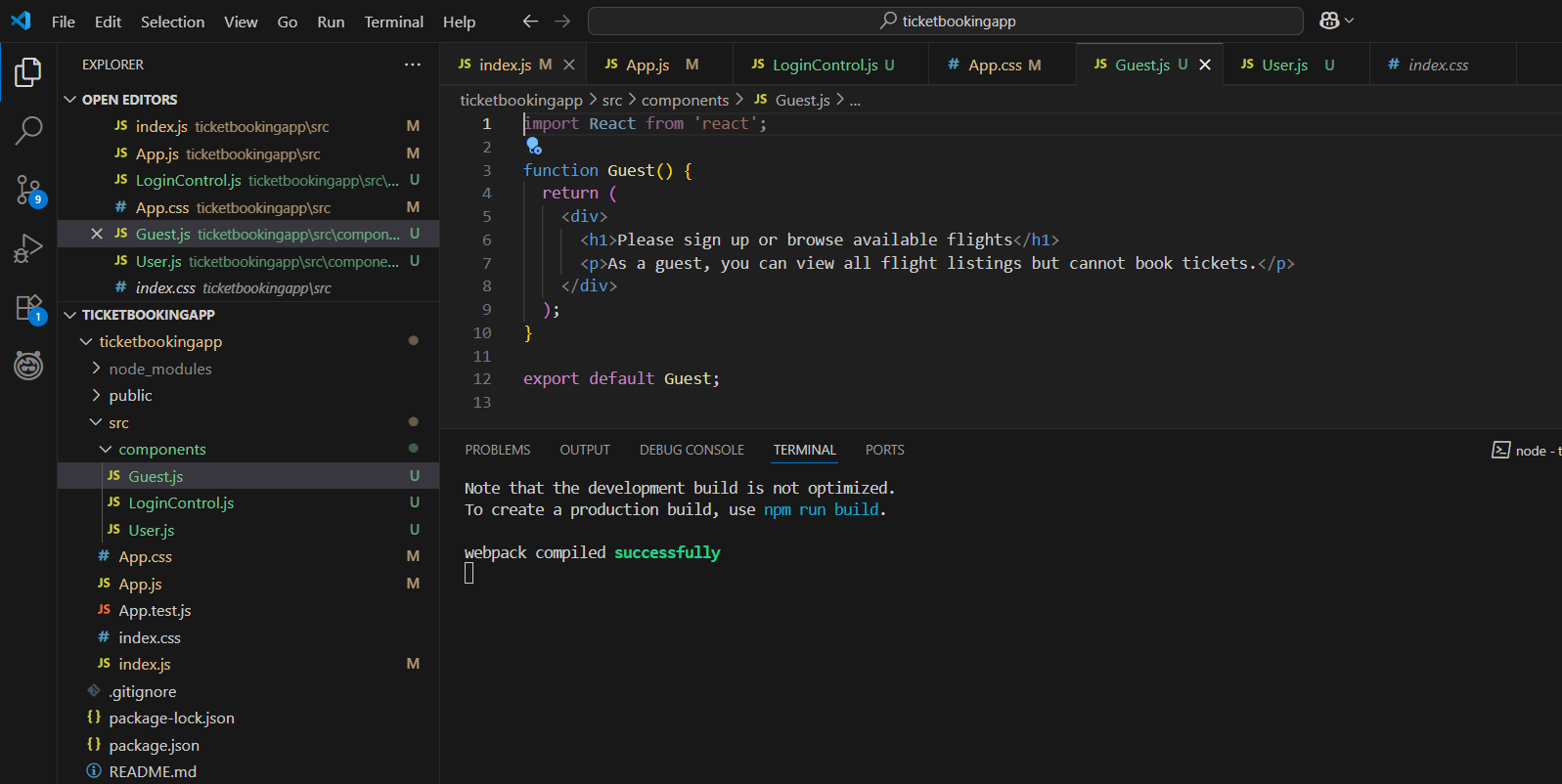

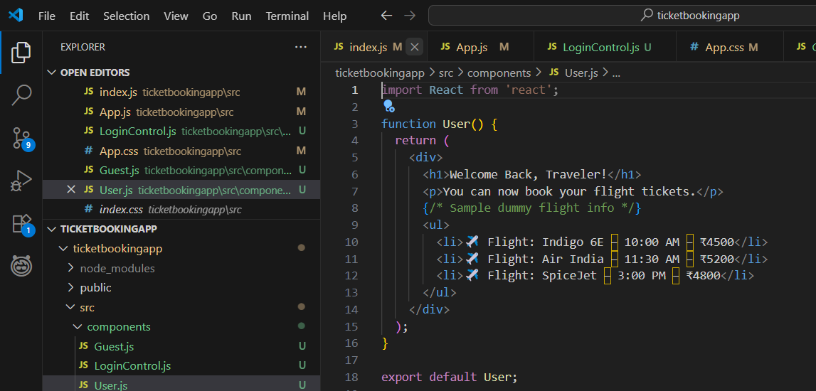

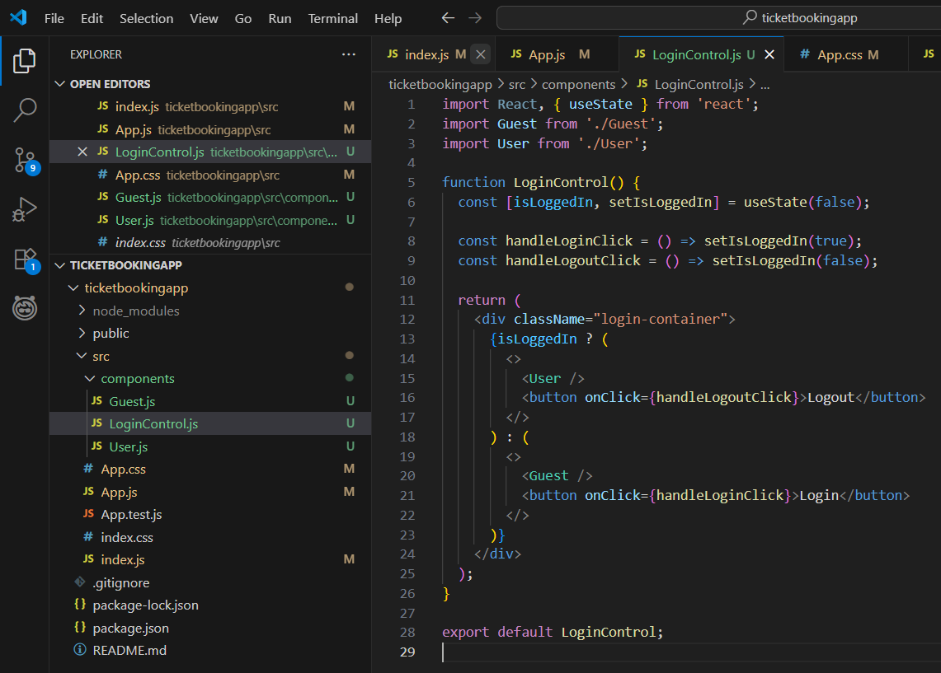

* **App.js**

import React from 'react';

import './App.css';

import LoginControl from './components/LoginControl';

function App() {

  return (

    <div className="App">

      <LoginControl />

    </div>

  );

}

export default App;

* **App.css**

.App {

  text-align: center;

  padding: 50px;

  font-family: 'Segoe UI', sans-serif;

}

.login-container h1 {

  font-size: 2rem;

  color: #1a1a1a;

}

.login-container p {

  font-size: 1.2rem;

  color: #333;

}

.login-container button {

  margin-top: 20px;

  padding: 10px 25px;

  background-color: #007bff;

  border: none;

  border-radius: 8px;

  color: white;

  font-size: 1rem;

  cursor: pointer;

}

.login-container button:hover {

  background-color: #0056b3;

}

ul {

  text-align: left;

  max-width: 400px;

  margin: 20px auto;

  font-size: 1rem;

  padding: 0;

  list-style-type: none;

}

li {

  background: #f4f4f4;

  margin-bottom: 10px;

  padding: 10px;

  border-radius: 6px;

}

* **Index.js**

import React from 'react';

import ReactDOM from 'react-dom/client';

import App from './App';

const root = ReactDOM.createRoot(document.getElementById('root'));

root.render(<App />);

* **Index.css**

body {

  margin: 0;

  font-family: -apple-system, BlinkMacSystemFont, 'Segoe UI', 'Roboto', 'Oxygen',

    'Ubuntu', 'Cantarell', 'Fira Sans', 'Droid Sans', 'Helvetica Neue',

    sans-serif;

  -webkit-font-smoothing: antialiased;

  -moz-osx-font-smoothing: grayscale;

}

code {

  font-family: source-code-pro, Menlo, Monaco, Consolas, 'Courier New',

    monospace;

}

**OUTPUT:**

